NOTICE OF PUBLIC HEARING
September 19th, 2019 at 7:00 pm
There will be a Public Hearing on Thursday, September 19th 2019, starting at 7:00 p.m. in the Shaw Auditorium at the Vancouver Island Conference Centre at 80 Commercial Street, Nanaimo, BC, to consider proposed amendments to the “City of Nanaimo Official Community Plan Bylaw 2008 No. 6500” and the “City of Nanaimo Zoning Bylaw 2011 No. 4500”.

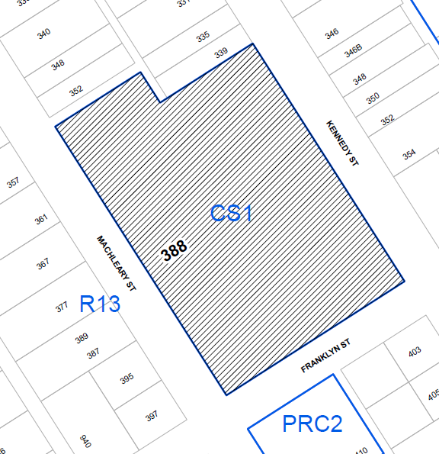
All persons who believe their interest in property is affected by the proposed bylaws will be given the opportunity to be heard in person, by a representative, or by written submission, on the matters contained within Bylaw No. 6500.040 and Bylaw No. 4500.124 at the Public Hearing.
Map A

Location: | 388 Machleary Street, as shown on Map A
File No.: | Official Community Plan Amendment Application - OCP00089
BYLAW NO. 6500.040

This bylaw, if adopted, will re-designate the subject property from Neighbourhood to Corridor in the Official Community Plan and amend the land use designation in the Old City Neighbourhood Concept Plan to allow a 175-unit multi-family development.

Location: | 388 Machleary Street, as shown on Map A
File No.: | Rezoning Application - RA000395
BYLAW NO. 4500.124
This bylaw, if adopted, will rezone the subject property from Community Service One (CS1) to Comprehensive Development Eleven (CD11) to allow a 175-unit multi-family development.

The subject property is legally described as LOT A, SECTION 1, NANAIMO DISTRICT, PLAN VIP53876

This bylaw, if adopted, will rezone the subject property from Community Service One (CS1) to Mixed-Use Corridor (COR2).
The subject property is legally described as LOT A, SECTION 1, NANAIMO DISTRICT, PLAN EPP35387

This bylaw, if adopted, will rezone the subject property from Community Service One (CS1) to Mixed-Use Corridor (COR2).
The subject property is legally described as LOT A, SECTION 1, NANAIMO DISTRICT, PLAN EPP35387

This bylaw, if adopted, will rezone the subject property from Community Service One (CS1) to Mixed-Use Corridor (COR2).
The subject property is legally described as LOT A, SECTION 1, NANAIMO DISTRICT, PLAN EPP35387

N

Subject Property

WANT TO MAKE A WRITTEN SUBMISSION?

If you are unable to attend the Public Hearing, written submissions must be received no later than 4:00 p.m., September 19th, to ensure their availability to Council at the Public Hearing. Written submissions can be provided by any of the following methods:
IN PERSON: Drop off at the Service and Resource Centre, located at 411 Dunsmuir Street
BY EMAIL: public.hearing@nanaimo.ca
WEBSITE: Submit comments directly through the City’s website at www.nanaimo.ca/publichearing
MAIL TO: City of Nanaimo, Development Services Department, 455 Wallace Street, Nanaimo, BC, V9R 5J6

WANT TO FIND OUT MORE INFORMATION?
IN PERSON: A copy of the above-noted bylaw and related documents may be inspected from September 6th, 2019 to
September 19th, 2019, from 8:00 a.m. to 4:30 p.m., Monday through Friday (excluding statutory holidays), at the City of Nanaimo, Development Services Department front counter in the Service and Resource Centre, located at 411 Dunsmuir Street.
WEBSITE: What’s Building In My Neighbourhood?
Access rezoning and application information on the City’s webpage by typing in the relevant civic address or file number at: www.nanaimo.ca/whatsbuilding.

If you would like more information about Public Hearings please go to the City website at www.nanaimo.ca and use the search function to find the ‘Public Hearing Information Sheet’, which contains many frequently asked questions.

If you would like more information about Public Hearings please go to the City website at www.nanaimo.ca and use the search function to find the ‘Public Hearing Information Sheet’, which contains many frequently asked questions.

Following the close of a Public Hearing, no further submissions or comments from the public or interested persons can be accepted by members of City Council, as established by provincial case law. This is necessary to ensure a fair Public Hearing process and provide a reasonable opportunity for people to respond.

This Notice is published in accordance with Section 466 of the Local Government Act. Notice given by the Corporate Officer.

City of Nanaimo – Development Services Department, Service and Resource Centre
411 Dunsmuir Street www.nanaimo.ca
Phone: (250) 755-4429 Fax: (250) 755-4439

